**Ex. No.: 9 b.**

**Date:**  8/11/23

**A PYTHON PROGRAM TO IMPLEMENT K-MEANS MODEL**

**Aim:**

To implement a python program using a K-Means Algorithm in a model.

**Algorithm:**

1. Import Necessary Libraries:

Import required libraries like numpy, matplotlib.pyplot, and sklearn.cluster.

1. Load and Preprocess Data:

Load the dataset.

Preprocess the data if needed (e.g., scaling).

1. Initialize Cluster Centers:

Choose the number of clusters (K).

Initialize K cluster centers randomly.

1. Assign Data Points to Clusters:

For each data point, calculate the distance to each cluster center. Assign the data point to the cluster with the nearest center.

1. Update Cluster Centers:

Calculate the mean of the data points in each cluster. Update the cluster centers to the calculated means.

1. Repeat Steps 4 and 5:

Repeat the assignment of data points to clusters and updating of cluster centers until convergence (i.e., when the cluster assignments do not change much between iterations).

1. Plot the Clusters:

Plot the data points and the cluster centers to visualize the clustering result.

**PROGRAM:**

data = pd.read_csv('../input/k-means-clustering/KNN (3).csv') data.head(5)

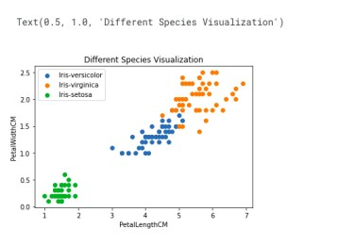

req_data = data.iloc[:,1:] req_data.head(5)

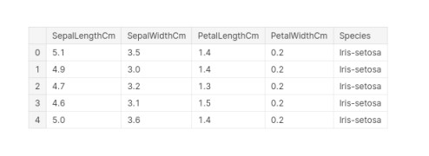

shuffle_index = np.random.permutation(req_data.shape[0])

#shuffling the row index of our dataset req_data = req_data.iloc[shuffle_index] req_data.head(5)

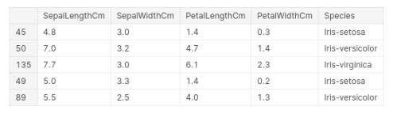

train_size = int(req_data.shape[0]*0.7) train_df = req_data.iloc[:train_size,:] test_df = req_data.iloc[train_size:,:] train = train_df.values test = test_df.values y_true = test[:,-1] print('Train_Shape: ',train_df.shape) print('Test_Shape: ',test_df.shape)

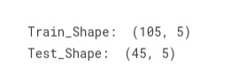

from math import sqrt def euclidean_distance(x_test, x_train):

distance = 0 for i in range(len(x_test)-1):

distance += (x_test[i]-x_train[i])**2 return sqrt(distance) def get_neighbors(x_test, x_train, num_neighbors):

distances = []

data = [] for i in x_train: distances.append(euclidean_distance(x_test,i)) data.append(i) distances = np.array(distances) data = np.array(data) sort_indexes = distances.argsort() #argsort() function returns indices by sorting distances data in ascending order data = data[sort_indexes] #modifying our data based on sorted indices, so that we can get the nearest neighbors return data[:num_neighbors] def prediction(x_test, x_train, num_neighbors):

classes = [] neighbors = get_neighbors(x_test, x_train, num_neighbors) for i in neighbors: classes.append(i[-1]) predicted = max(classes, key=classes.count) #taking the most repeated class return predicted def predict_classifier(x_test):

classes = [] neighbors = get_neighbors(x_test, req_data.values, 5) for i in neighbors: classes.append(i[-1])

predicted = max(classes, key=classes.count) print(predicted) return predicted def accuracy(y_true, y_pred):

num_correct = 0 for i in range(len(y_true)): if y_true[i]==y_pred[i]: num_correct+=1 accuracy = num_correct/len(y_true) return accuracy y_pred = [] for i in test:

y_pred.append(prediction(i, train, 5)) y_pred

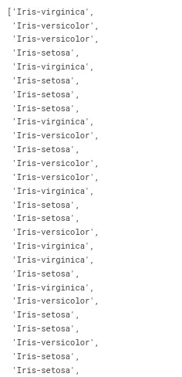

accuracy = accuracy(y_true, y_pred) accuracy



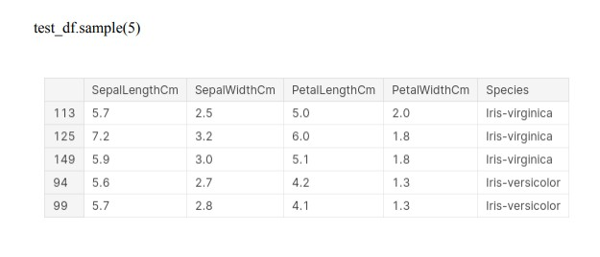

**RESULT:-**

Thus the python program to implement the K-Means model has been successfully implemented and the results have been verified and analyzed